
FACULTY OF ENGINEERING, SCIENCES AND TECHNOLOGY

DATABASE MANAGEMENT SYSTEMS LAB

PROJECT REPORT

INSTRUCTOR: SHOAIB AHMED

GROUP MEMBERS:
- BURHAN ALI (67491)
- EMAN LIAQUAT (67404)
- SADAF (67400)

- INTRODUCTION:
The Smart QuickBite Restaurant Management System is a user-friendly web application crafted to streamline restaurant operations. With this system, customers can easily browse through food options, choose combo deals, take advantage of discounts, place their orders, generate receipts, and share their feedback—all through an engaging interface. It accommodates various payment methods and keeps a comprehensive record of customer orders in a centralized database.
Built with technologies like HTML, CSS, JavaScript, Node.js, Express.js, and Microsoft SQL Server, this application efficiently manages data related to customers, food categories, menu items, deals, discounts, orders, payments, feedback, and order statuses. It employs key Database Management System principles such as normalization, primary and foreign keys, relationships, joins, stored procedures, triggers, indexing, and transactions to ensure data integrity and optimal performance. Plus, the system features dashboard analytics and reporting tools to enhance the monitoring and management of restaurant operations.
- SCOPE:
The Smart QuickBite Restaurant Management System is crafted to offer a unified platform for overseeing restaurant operations via a centralized database system. This project encompasses customer management, food category management, menu item management, order processing, payment handling, deal management, discount management, receipt generation, and customer feedback management. These features collaborate to enhance the efficiency and organization of restaurant activities.
The system facilitates the storage, retrieval, updating, and processing of restaurant data through a well-structured relational database. It preserves information pertaining to customers, food items, deals, discounts, orders, payments, order status, and feedback while ensuring data consistency and integrity. The integration of the web interface with the database allows for seamless interaction between users and the system for executing various restaurant-related tasks.
Moreover, the project integrates advanced database functionalities for effective data management and reporting. Features such as sales summaries, payment reports, dashboard analytics, order tracking, and database-driven decision support contribute to improved operational oversight. The system is designed to showcase the practical application of database technologies within a restaurant management context while ensuring reliability, accuracy, and efficient performance.
- SYSTEM OVERVIEW:
The Smart QuickBite Restaurant Management System is designed with a client-server architecture, allowing users to easily navigate the web interface to check out menu items, grab deals, apply discounts, and place their orders. When a user makes a request, the backend server springs into action, processing everything and storing transaction data in the SQL Server database.
Once an order is placed, the system takes care of validating customer information, logging order details, handling payment info, applying any discounts, and generating a receipt. All this stored data is then put to good use for dashboard analytics, sales reports, order tracking, payment summaries, and managing customer feedback. This streamlined workflow ensures that restaurant operations run smoothly and efficiently.
3.1 Customer (User) Component:
The Customer Component acts as the main interface for users interacting with the Smart QuickBite Restaurant Management System. It offers an intuitive platform for customers to access restaurant services and engage in various ordering tasks. This component is crafted to streamline the ordering experience while guaranteeing a seamless and effective user journey.
Functions:
- Customers can view available food items.
- Customers can search food items by category.
- Customers can select food quantities.
- Customers can choose combo deals.
- Customers can apply discount offers.
- Customers can place orders.
- Customers can generate receipts.
- Customers can submit feedback.
The following table summarizes the key inputs from customers, the processing conducted by the system, and the outputs produced during various operations.
Input | Process | Output
Customer Information | Order Processing | Order Confirmation
Food Selection | Bill Calculation | Receipt Generation
Feedback | Feedback Storage | Feedback Record
3.2 Food & Deal Management Component:
The Food & Deal Management Component oversees the management of menu-related data within the system. It keeps track of food categories, menu items, combo deals, pricing details, and promotional offers. This component guarantees that customers receive current menu information and available discounts while facilitating efficient restaurant operations. It also enables the system to categorize food products systematically.
Functions:
- The system stores food item details.
- The system manages food categories.
- The system manages combo deals.
- The system manages discount offers.
- The system displays food images and prices.
- The system updates menu information.
The following table outlines the primary entities handled by this component and their respective functions within the system.
Entity | Description
Food Categories | Classification of food items
Food Items | Menu products available for ordering
Combo Deals | Multiple food items offered at special prices
Discounts | Student, Eid, HBL, Meezan and other promotional offers
3.3 Order & Payment Component:
The Order & Payment Component is essential for managing customer transactions within the restaurant management system. It oversees the placement of orders, calculation of bills, application of discounts, recording of payments, generation of receipts, and tracking of orders. This component guarantees that all information related to transactions is processed accurately and securely stored in the database.
Functions:
- The system processes customer orders.
- The system stores order details.
- The system calculates the total bill.
- The system applies discounts and offers.
- The system records payment information.
- The system generates order receipts.
- The system tracks order status.
The table below outlines the key processes executed by this component along with their respective descriptions.
Process | Description
Order Placement | Customer selects food items and deals
Bill Calculation | System calculates subtotal and final amount
Discount Processing | Selected discount offer is applied
Payment Recording | Payment details are stored in database
Receipt Generation | Receipt is generated after successful order
Order Tracking | Order status is monitored and updated
- DATABASE DESIGN:
The Smart QuickBite Restaurant Management System's database is structured using the relational database model, which facilitates effective storage, management, and retrieval of restaurant-related data. This design features several interconnected tables that hold information about customers, food categories, menu items, deals, orders, payments, and order statuses. Relationships among entities are defined through primary and foreign keys, ensuring consistency and integrity across the database.
The database architecture has been crafted following normalization principles to reduce redundancy and enhance data organization. A clearly defined schema enables the system to accommodate various functionalities, including order processing, payment management, receipt generation, sales reporting, dashboard analytics, and customer feedback management.
  - Database Features
The database includes various features that enhance efficient data management, dependable transaction processing, and overall system performance. These features guarantee that information is organized systematically while upholding consistency, accuracy, and security across the database environment.
- Relational Database Structure
- Entity Relationship Model (ERD)
- Primary Key and Foreign Key Relationships
- Normalized Database Design
- Data Integrity and Consistency
- Efficient Data Retrieval and Query Processing
- Support for Reporting and Analytics
- Secure Storage of Operational Data
  - Entity Relationships:
The components within the database are linked by clearly established relationships that cater to the operational needs of the system. These relationships enable data exchange between various modules while maintaining referential integrity and reducing data redundancy.The primary relationships recognized within the database are outlined below:
- One Customer can place multiple Orders.
- One Order can contain multiple Menu Items.
- Each Menu Item belongs to one Category.
- One Order is associated with one Payment record.
- Customers can submit Feedback for completed orders.
- Discounts and Deals can be applied to eligible orders.
- Order Status is used to monitor order progress from placement to delivery.

- DATABASE OPERATIONS:
The Smart QuickBite Restaurant Management System employs a range of database operations to facilitate data processing, transaction management, and analytical reporting. These operations allow the system to effectively store, retrieve, update, and manage information while ensuring accuracy and consistency across all database entities.
The implementation integrates various DBMS concepts and techniques that enhance effective database management and system performance. These concepts were applied during the development of several modules, including customer management, order processing, payment handling, feedback management, dashboard analytics, and report generation.
5.1 Implemented DBMS Concepts:
- Database Creation and Table Management
- Entity Relationship Modeling (ERD)
- Relational Database Design
- Primary Key Constraints
- Foreign Key Constraints
- Unique and Not Null Constraints
- Database Normalization (1NF, 2NF, 3NF, BCNF)
- CRUD Operations (Create, Read, Update, Delete)
- Aggregate Functions (COUNT, SUM, AVG, MAX, MIN)
- Group By Operations
- SQL Joins (INNER JOIN, LEFT JOIN)
- Subqueries
- Stored Procedures
- Triggers
- Indexing
- Transactions and Rollbacks
The table below outlines the key DBMS concepts applied in the project and their respective contributions to supporting system functionality and database performance
Concept | Usage in Project
ERD | Designing relationships between entities
Constraints | Maintaining data integrity
Normalization | Reducing data redundancy
CRUD | Managing customers, orders, and feedback
Aggregate Functions | Dashboard statistics and reports
Joins | Retrieving data from multiple tables
Subqueries | Analytical queries and reporting
Stored Procedures | Dashboard and report generation
Triggers | Automatic database logging
Indexing | Faster data retrieval
Transactions | Secure order processing
- METHODOLOGY:
The Smart QuickBite Restaurant Management System was created using a structured approach to guarantee the systematic design, implementation, and assessment of the proposed solution. This methodology comprised several phases that included requirement analysis, database design, application development, database implementation, and system testing. Each phase played a vital role in the successful creation of a dependable and efficient restaurant management system.
6.1 Development Phases:
Phase 1: Requirement Analysis
The first phase concentrated on determining the functional and database requirements of the system. Key requirements encompassed customer management, menu management, deal and discount management, order processing, payment handling, receipt generation, dashboard analytics, reporting, and feedback management.
Phase 2: Database Design
In this phase, the Entity Relationship Diagram (ERD) was crafted to represent the entities, attributes, and relationships necessary for the system. The database schema was designed and normalized to ensure data consistency, eliminate redundancy, and uphold referential integrity through primary and foreign key constraints.
Phase 3: Application Development
The user interface was constructed using HTML, CSS, and JavaScript, while Node.js and Express.js were employed for backend processing. The application modules were designed to facilitate food ordering, deal management, payment processing, receipt generation, dashboard analytics, and customer feedback functionalities.
Phase 4: Database Implementation
The database was established using Microsoft SQL Server. Various DBMS concepts, including CRUD operations, joins, aggregate functions, subqueries, stored procedures, triggers, indexing, and transaction management, were integrated to enable efficient data processing and retrieval.
Phase 5: Testing and Validation
The concluding phase focused on testing and validating each system module to confirm database relationships, transaction precision, report generation, order processing, payment management, and the overall functionality of the system. This testing phase guaranteed that the system operated reliably and fulfilled the specified requirements.
The comprehensive methodology employed for developing the Smart QuickBite Restaurant Management System is depicted in the flowchart shown below.
6.2 FLOWCHART / ERD DIAGRAM:

- DATA COLLECTION:
The Smart QuickBite Restaurant Management System is crafted to gather, organize, and oversee data essential for restaurant operations within a centralized database framework. Data gathering is a core element of the system, allowing for precise order processing, payment handling, reporting, customer engagement, and analytical decision-making. The information collected is housed in a structured relational database to guarantee consistency, integrity, and efficient access.
The system retains data concerning customers, their contact details, food categories, menu offerings, combo deals, discount promotions, orders, payments, feedback, and order statuses. Each dataset plays a role in executing specific business processes and enhances the overall functionality of the application. The information gathered is also used for transaction processing, dashboard analytics, sales reporting, payment summaries, and customer service management.
The Smart QuickBite Restaurant Management System utilizes a thorough and methodical data collection framework to bolster the effective execution of restaurant operations. Data gathering is a vital component of the system, ensuring that all operational, transactional, and customer-related information is accurately captured, validated, and stored within a centralized relational database. This organized approach promotes smooth order management, payment processing, customer interaction, performance tracking, and informed business decision-making.
The system collects and manages data from various operational areas, such as customer profiles, menu management, promotional campaigns, order transactions, payment activities, and customer feedback. Each data category is meticulously organized to facilitate specific business functions while ensuring consistency, integrity, security, and accessibility of the data. The information gathered forms the basis for generating analytical insights, tracking business performance, creating management reports, and improving overall service quality.
Data Stored in the System:
- Customer information including names, phone numbers, and email addresses.
- Food category and menu item details including names, prices, descriptions, images, and availability status.
- Combo deals and promotional discount offers such as Student Discounts, Eid Discounts, HBL Card Discounts, and other promotional schemes.
- Order details including order identifiers, customer references, order dates, discount values, and final payable amounts.
- Order detail records including selected food items, deal items, quantities, and calculated totals.
- Payment details including payment methods, payment status, and transaction records.
- Customer feedback information including ratings, comments, and feedback submission dates.

The data collected is crucial in supporting essential business processes such as order fulfillment, sales tracking, financial reporting, customer relationship management, and dashboard analytics. By ensuring accurate and well-organized data, the system promotes efficient database operations and supports the application of key database management principles throughout the system.
- ANALYSIS:
The Smart QuickBite Restaurant Management System underwent a thorough analysis concerning its database structure, operational efficiency, data management capabilities, and the implementation of database management principles. This evaluation concentrated on assessing the effectiveness of the relational database design and the interactions among various system components that oversee restaurant operations.
The database schema reveals a well-organized design where multiple entities are linked through primary and foreign key relationships. The use of normalization techniques plays a crucial role in minimizing redundancy and enhancing data consistency, while database constraints uphold the accuracy and integrity of the stored data. Additionally, advanced database features such as joins, aggregate functions, stored procedures, triggers, indexing, and transaction management support efficient data processing and retrieval. The analysis concludes that the proposed system effectively merges restaurant management functions with database operations, offering a dependable platform for managing customer orders, payment records, reporting activities, and feedback management.
- RESULTS:
The Smart QuickBite Restaurant Management System was successfully deployed and integrated with Microsoft SQL Server. The application developed allows customers to explore menu items, select food products, apply discounts, choose payment options, place orders, generate receipts, and provide feedback through an engaging web interface. The successful implementation of these features illustrates the system's effectiveness in facilitating restaurant operations.
Moreover, the system offers dashboard analytics, payment summaries, sales reports, search functionalities, and order tracking capabilities that improve operational oversight and management. Database transactions were carried out accurately, ensuring reliable storage and retrieval of information across all application modules. The results of the implementation validate the effective application of database principles such as normalization, table relationships, CRUD operations, joins, aggregate functions, stored procedures, triggers, indexing, and transaction management. These elements work together to enhance data organization, streamline processing, and ensure dependable system performance.
Website homepage / dashboard:
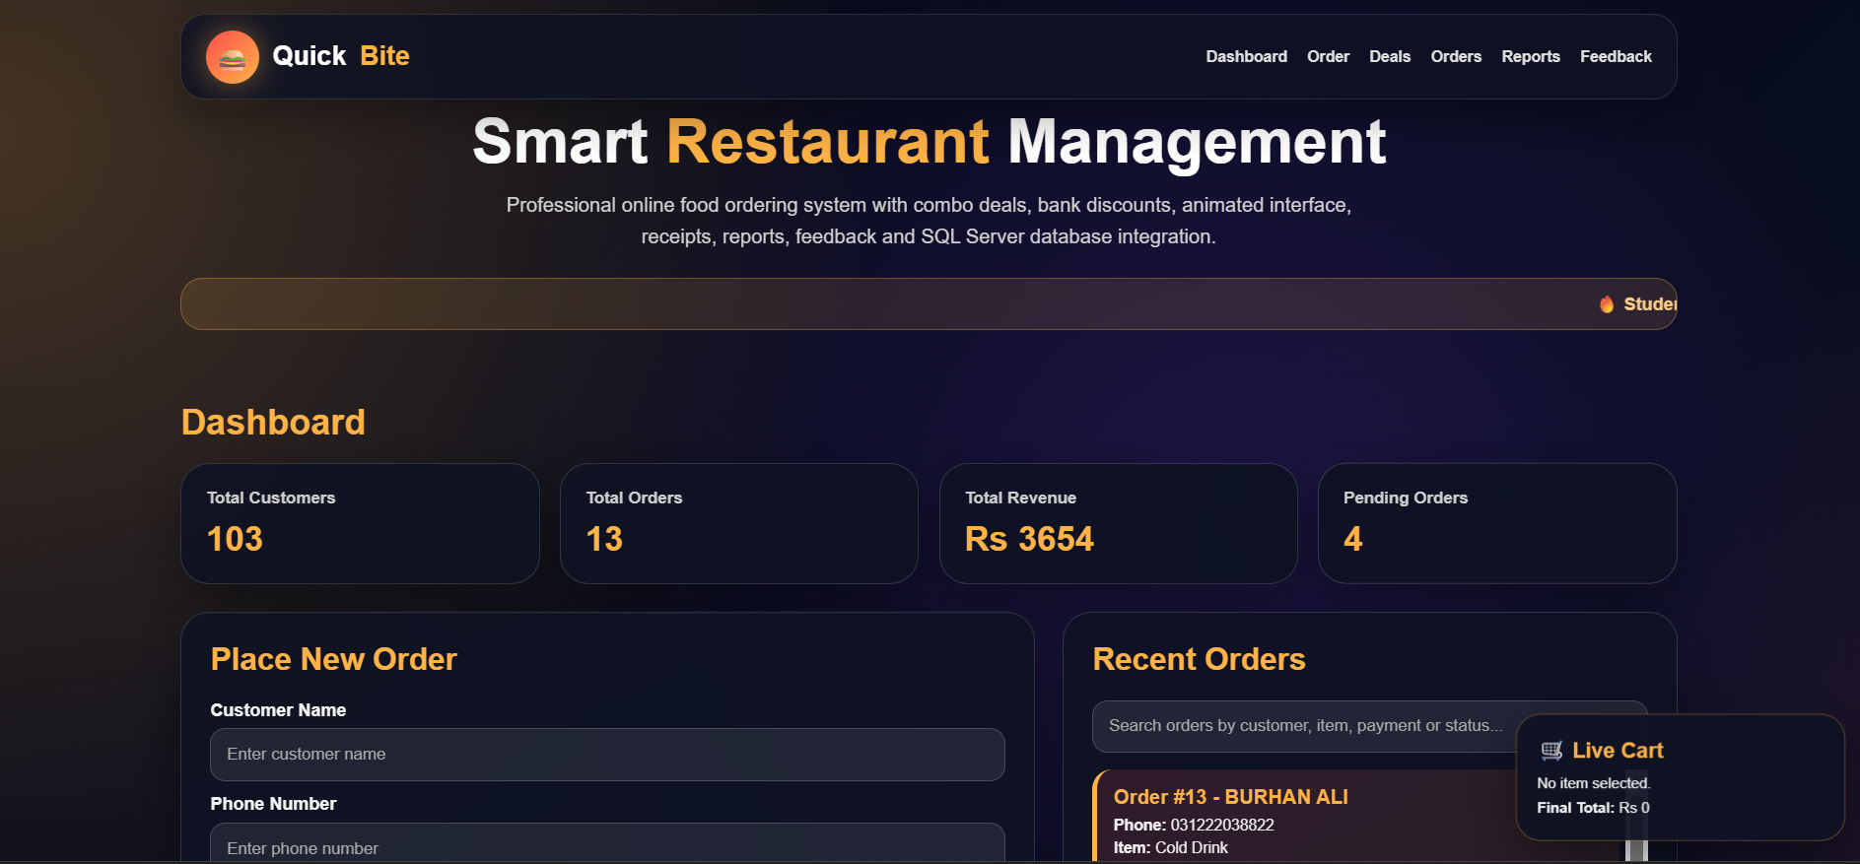
Menu items with images:
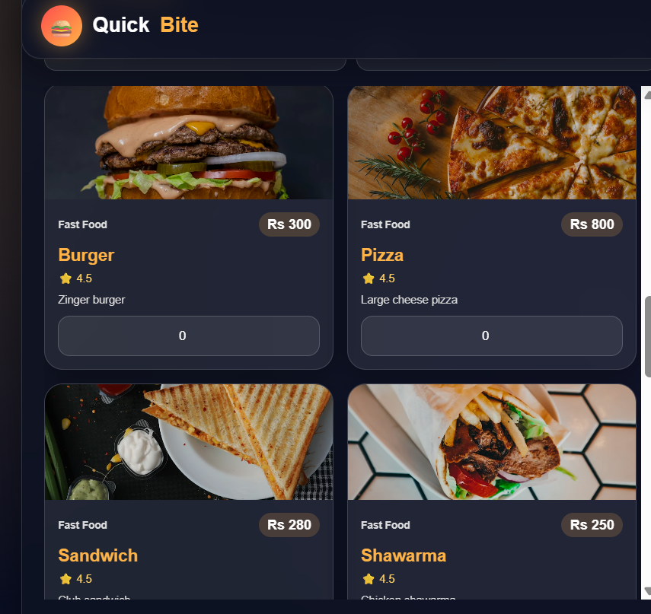
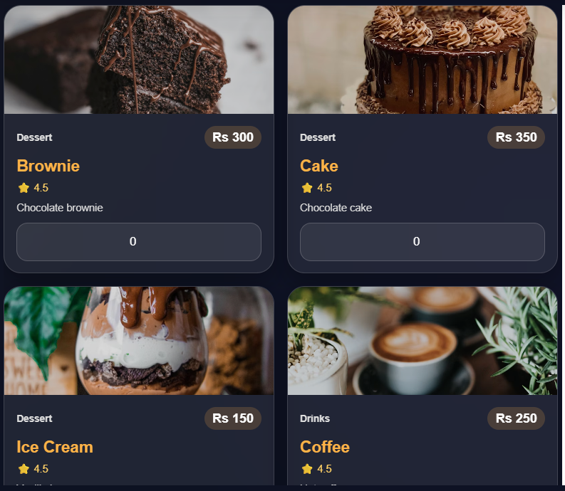
Combo deals and discounts:
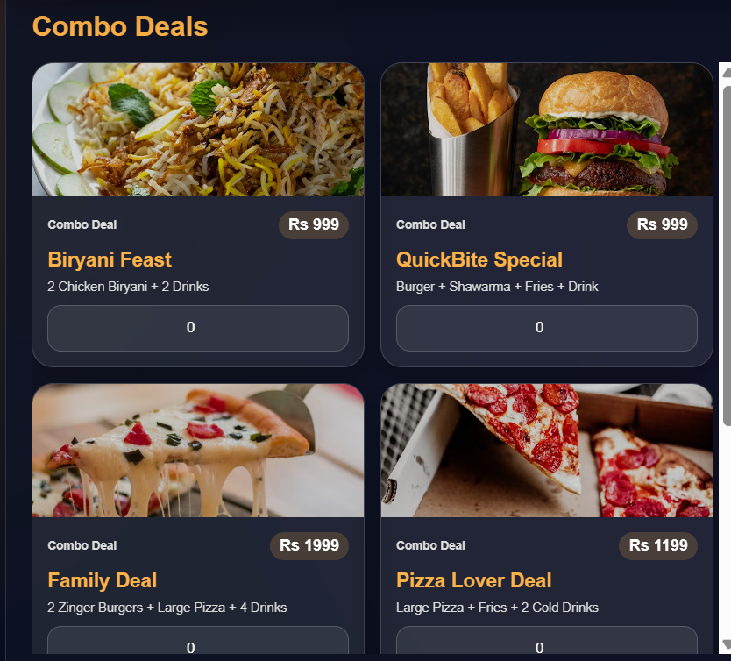
Order placement:
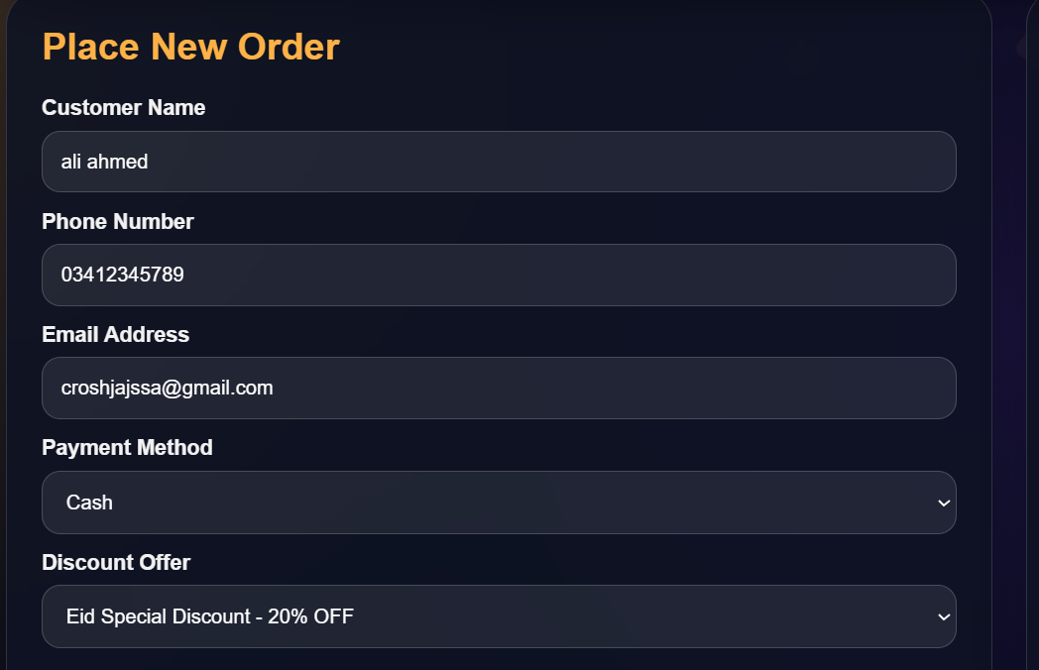
Receipt generation:
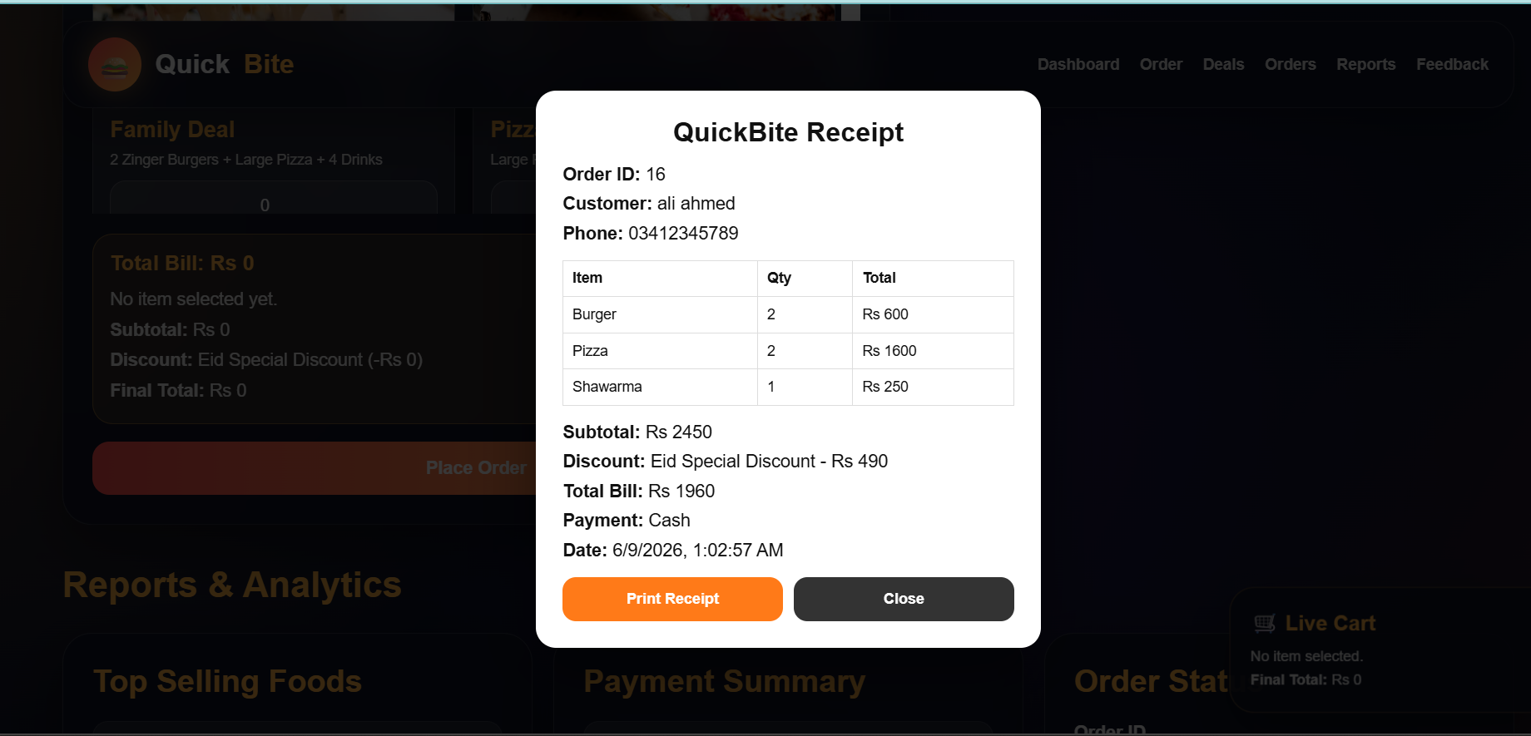
Recent orders:
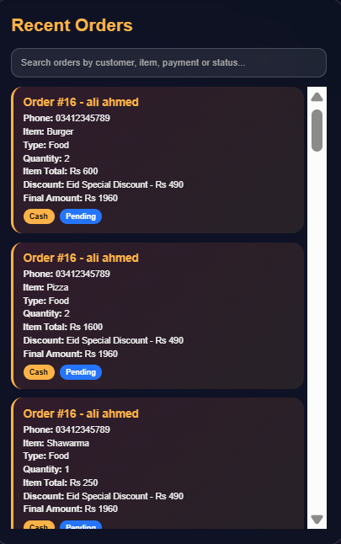
Feedback section:
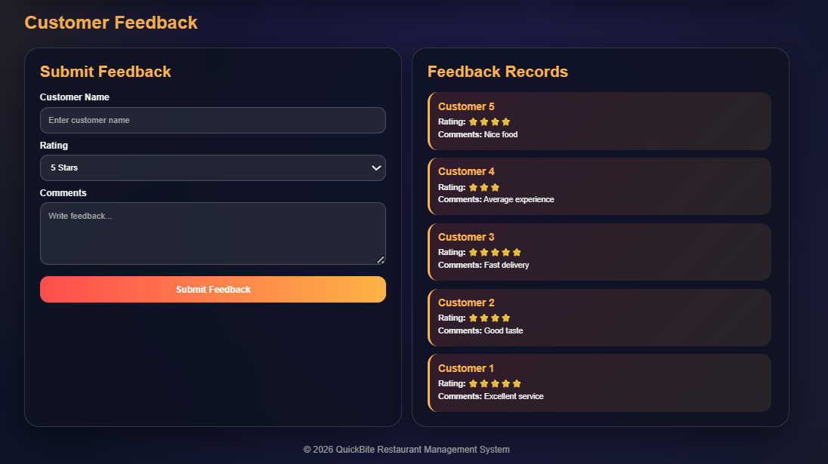
SQL Server tables / query output: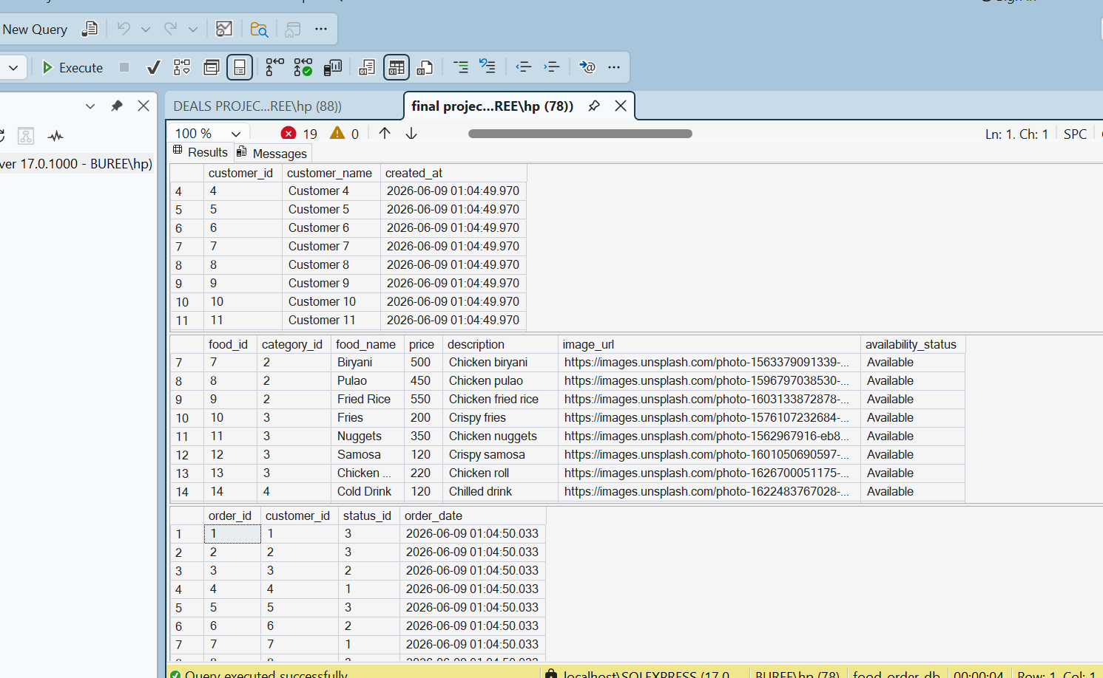

10. DISCUSSION ON RESULTS:
‎The outcomes from the implementation and testing stages reveal that the Smart QuickBite Restaurant Management System successfully meets its intended goals. The consolidation of customers, menu items, deals, discounts, orders, payments, and feedback within a unified database framework greatly enhances data organization and accessibility.
The application of relational database principles and sophisticated DBMS concepts plays a crucial role in preserving data integrity, minimizing redundancy, and improving processing efficiency. Features like dashboard analytics, reporting tools, transaction management, and automated database functions add further value by facilitating decision-making and operational oversight. In summary, the findings indicate that the proposed system offers an effective, reliable, and scalable solution for restaurant management while adeptly implementing the database concepts and techniques explored throughout the DBMS laboratory course.
‎11. CONCLUSION:
‎The Smart QuickBite Restaurant Management System is a great example of how Database Management System concepts can be applied in a real-world restaurant setting. It offers an effective way to manage customers, food items, deals, discounts, orders, payments, receipts, and feedback through a centralized database. This project successfully implemented crucial DBMS concepts such as database design, normalization, relationships, CRUD operations, joins, aggregate functions, stored procedures, triggers, indexing, and transactions. Overall, it has deepened our understanding of database management and web application development while providing a scalable and well-organized solution for restaurant management.
REFERENCES:
- Elmasri, R., & Navathe, S. B. Fundamentals of Database Systems. Pearson Education.
- Korth, H. F., Silberschatz, A., & Sudarshan, S. Database System Concepts. McGraw-Hill Education.
- 3.[Microsoft SQL Server Documentation](https://learn.microsoft.com/en-us/sql/sql-server/?utm_source=chatgpt.com)
- [Node.js Official Documentation](https://nodejs.org/en/docs?utm_source=chatgpt.com)
- [Express.js Documentation](https://expressjs.com/?utm_source=chatgpt.com)
- [MDN Web Docs (HTML, CSS, JavaScript)](https://developer.mozilla.org/?utm_source=chatgpt.com)

